DAY 3 ACTIVITY

Entity-Relationship Diagrams: Practice Activities
Guided Activity (as a class) → Independent Practice (individually or in pairs, 15–20 minutes)

Notation Key
| | One
◁ | Many
- - - | Non-identifying relationship
—— | Identifying relationship

Part 1 — Read Finished Activity: Gym Database ERD
Read through this example step by step.
Scenario
A gym needs to track its members, classes, and instructors.
- Members: Member ID, First Name, Last Name, Phone, Email
- Classes: Class ID, Class Name, Date/Time
- Instructors: Instructor ID, First Name, Last Name, Phone
Business Rules
- A member can sign up for many classes.
- A class can have many members.
- An instructor can teach many classes.
- A class is taught by one instructor.
Task
Create an ERD for this scenario, using IDEF1X notation.

Step 1 — Identify Entities
Entity
MEMBER
CLASS
INSTRUCTOR

Step 2 — Identify Attributes

MEMBER | CLASS | INSTRUCTOR
Member ID (PK) | Class ID (PK) | Instructor ID (PK)
First Name | Class Name | First Name
Last Name | Date/Time | Last Name
Phone | Instructor ID (FK) | Phone
Email

Step 3 — Identify Relationships

Entity A | Relationship | Entity B | Type
MEMBER | signs up for | CLASS | M:N
INSTRUCTOR | teaches | CLASS | 1:M

Step 4 — Resolve the Many-to-Many Relationship
A member-to-class relationship is many-to-many (M:N), which IDEF1X cannot represent directly. We resolve it by creating an associative entity that sits between MEMBER and CLASS.
Associative Entity | Contains
ENROLLMENT | Member ID (FK), Class ID (FK), Enrollment Date — PK = Member ID + Class ID

Completed ERD (IDEF1X Notation)
Here is the finished diagram for the Gym Database. Use this as your reference for the notation (base entities, associative entity, PK/FK placement, cardinality) as you move into Part 2.
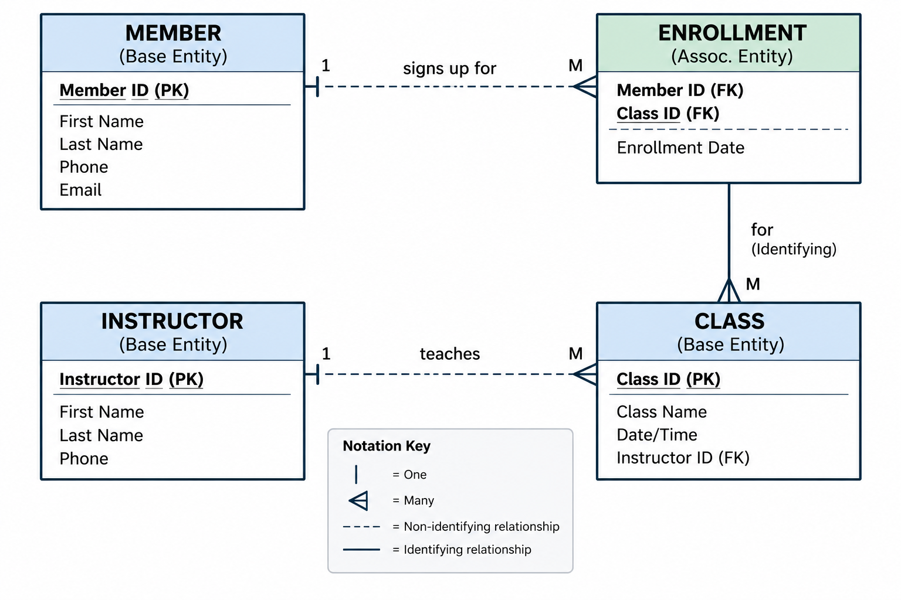

Part 2 — Independent Practice: Veterinary Clinic
Work individually. You have 15–20 minutes. Use the blank worksheet below to work through each step — do not skip ahead to drawing the diagram until Steps 1–5 are done.
Scenario
A veterinary clinic needs a database to track animals, owners, and appointments.
- Owners: Owner ID, Name, Phone, Address
- Animals: Animal ID, Name, Species, Breed, Date of Birth, Owner ID
- Appointments: Appointment ID, Date, Time, Animal ID
Business Rules
- An owner can have many animals.
- An animal belongs to exactly one owner.
- An animal can have many appointments.
- An appointment is for exactly one animal.
Your Tasks
- Identify all entities.
- Identify all attributes for each entity.
- Identify the primary key for each entity.
- Identify the relationships between entities.
- Determine the cardinality of each relationship.
- Draw the ERD using IDEF1X notation.

Step 1 — Identify Entities
List each entity below.
Entity | Type

Step 2 — Identify Attributes
Fill in the attributes for each entity, including primary keys (PK) and foreign keys (FK).
OWNER | ANIMAL | APPOINTMENT

Step 3 — Identify Relationships
Name each relationship and its cardinality (1:1, 1:M, or M:N).
Entity A | Relationship | Entity B | Type

Step 4 — Draw the ERD
On a separate sheet, in your notebook, or in your diagramming tool, draw the full IDEF1X ERD for the Veterinary Clinic — base entities, primary/foreign keys, cardinality (1 / M), and identifying vs. non-identifying relationships (solid vs. dashed lines). Use the Gym Database diagram from Part 1 as your notation reference.
Completed Diagram Example:
